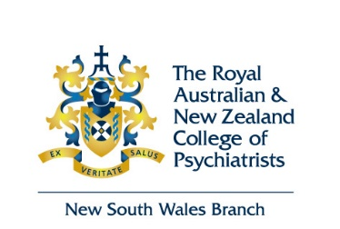

NSW BRANCH MERITORIOUS SERVICE AWARD 2022

The New South Wales Branch Committee seeks to recognise those individuals and/or agencies who have significant, sustained and distinguished service and/or have made an outstanding contribution to the practice of psychiatry in a clinical, academic, research, training, advocacy or administrative capacity in NSW.

The Meritorious Service Award is presented on an annual basis to a:

- Fellow of the College in New South Wales
AND may also be awarded to:

- An Agency or individual in New South Wales who is not a College Member,

In weighing up the relative merits of a range of nominated individuals, the selection panel of the NSW Branch Committee may take into consideration whether a particular nominee's achievements have been conducted substantially in NSW and if they have already received significant public recognition of their contribution.

Winners receive an engraved a medallion and a certificate presented at the Annual Dinner of the NSW Branch by the Chair of the NSW Branch Committee.

Nominations close on Monday 22 August 2022

The NSW Branch Committee is now seeking nominations from NSW Fellows for these awards.

To nominate please complete the following form and return with an abridged CV of the nominee to the NSW Branch Manager email: Ken.Branighan@ranzcp.org.

I, ________________________________________________________(name of nominating Fellow)
would like to Nominate: (please select as applicable and add name(s))

Fellow: _____________________________________________

Agency/Non-College Fellow: _____________________________________________

For the RANZCP NSW Branch Meritorious Service Award because*:

______________________________________________________________________________
* If you need additional space for your explanation, please attach a separate sheet with this nomination.
NB: an abridged CV of the person (or agency) being nominated is to be forwarded with this nomination

